Introduction to Bootstrap Framework for Responsive Web Sites

What is Bootstrap?
“Bootstrap is the most popular HTML, CSS, and JavaScript framework for developing responsive, mobile-first web sites.” – From W3Schools Bootstrap 5 Tutorial

Why Use It?
- Responsive Web Design: lots of built-in (“out of the box”) features to ensure that your site looks great across all types/sizes of devices
- NavBar: Beautiful menus!
- Consistent look and feel: buttons, menus, headings, lists, and many other Web page components
- Themes: Many lovely themes available to change the colors and other aspects of appearance just by swapping out a file! See Bootswatch for a nice selection of free downloadable themes

How to Get Bootstrap into Your Web Project
Bootstrap consists of JavaScript and CSS files that need to be added to your project. The files can either be copied to your website’s file folders OR you can link to files hosted on a CDN (Content Delivery Network)

Edit an existing Web project or create a new one:
- Open one of your existing websites on your computer or your online coding environment or create a new website project
- For our demo, we will use Replit: Go to https://replit.com
  - Click the Create Repl button and select Template HTML, CSS, JS
    - change the Title if you want – our example is Hack for the World Intergalactic
    - click + Create Repl button
    - 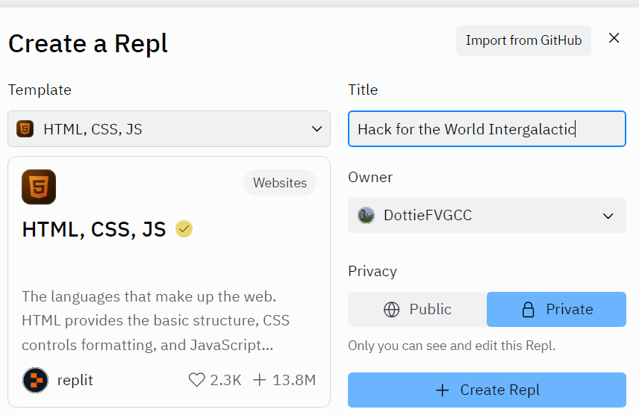
  - Select the index.html file in the editor
  - View in the Browser by clicking the green Run button to see how the page looks with the default formatting

Get Bootstrap and add to your project
- Bootstrap consists of a CSS file and a JavaScript file that need to be added to your page
- Go to https://getbootstrap.com/
- Scroll down to find Include via CDN
- Get the CSS (Cascading Style Sheet)
  - Click the copy icon to the right of the first link to copy it to the clipboard
  - Go to your index.html page and paste the copy inside the <head> element before your project-specific stylesheet, such as style.css
- Get the JavaScript:
  - Click the copy icon to the right of the second link to copy it to the clipboard
  - Go to your index.html page and paste the copy just above the closing </body> tag
  - JS goes just before the closing </body> tag
- This initial example uses the CDN (Content Delivery Network) source for the CSS and JavaScript files, i.e., the files are hosted in the cloud rather than copied to your project
- Take another look at your project in the Browser; depending on what content you have on your page you may see differences from the previous appearance
Insert Bootstrap stylesheet link in <head> before your project-specific stylesheet(s)
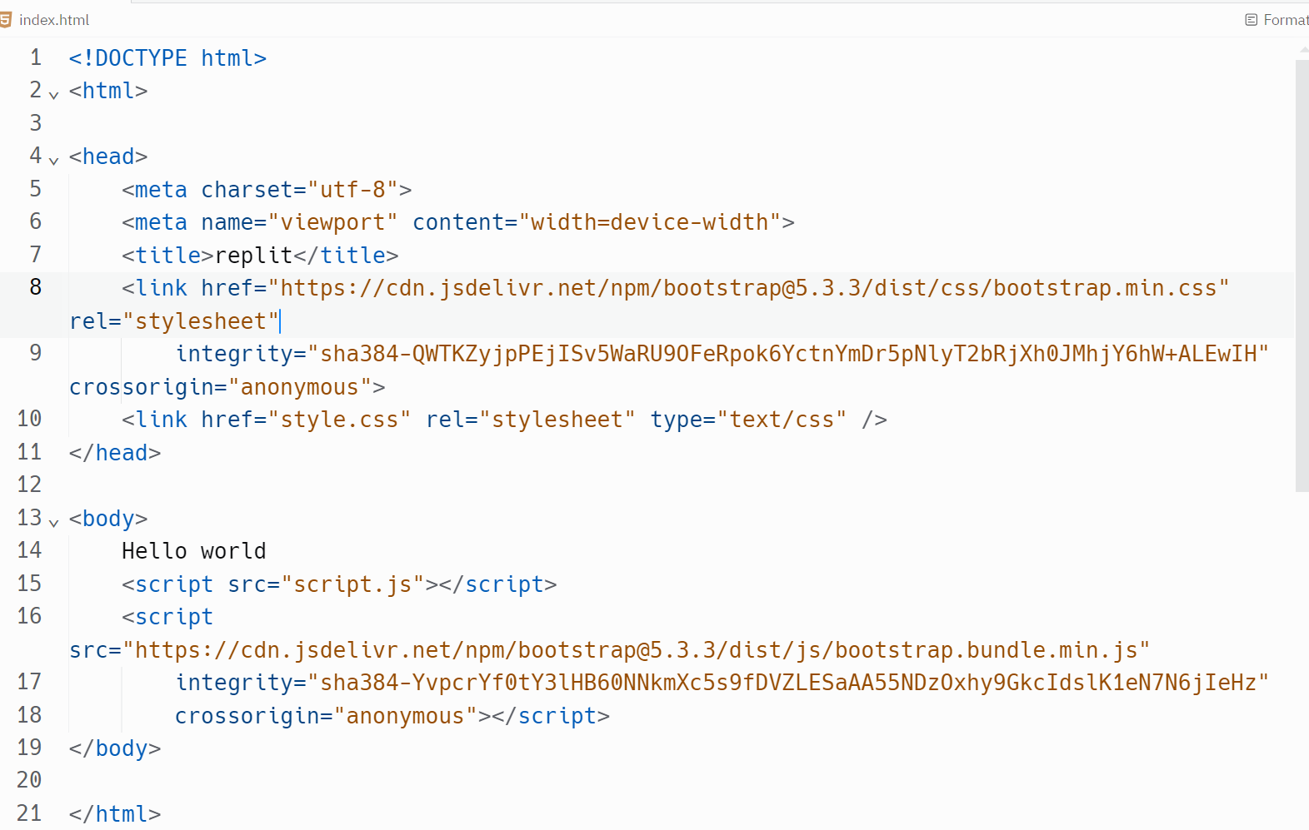
Insert Bootstrap bundle which includes JQuery, Popper, and Bootstrap JavaScript above closing </body> tag

Bootstrap Basics: Containers and Classes
- Bootstrap’s Container elements are the basic units of the layout and are required in order to use the Grid System
  - We will “wrap” our entire content inside a container so that Bootstrap styles are applied to all the elements
  - Right below the <body> tag add <div class="container">
  - Right above the </body> tag add the matching closing tag </div>
- Bootstrap’s Grid System uses rows and columns within a container to layout the content. The grid system is responsive and will adjust placement of columns when the page is resized
- Bootstrap uses CSS classes to define the appearances of HTML elements so that you can easily make changes to appearances just by modifying classes!

Add some features to showcase Bootstrap’s Power

Navigation
- Go to https://getbootstrap.com/docs/5.3/components/navbar/
- Scroll to the first code example under “Supported Content”
- Click “Copy” in the upper right of the Navbar example
- Paste it into your project right under the <body> tag, i.e., at the start of the content
- Add a header below the Navbar <h2>We are adding Bootstrap to our site!</h2>
- View your page in the Browser again
- Resize the Window or look at your site on your phone to see the Responsive design: The bar menu changes to the “hamburger” menu when the screen is smaller and expands on a larger screen!
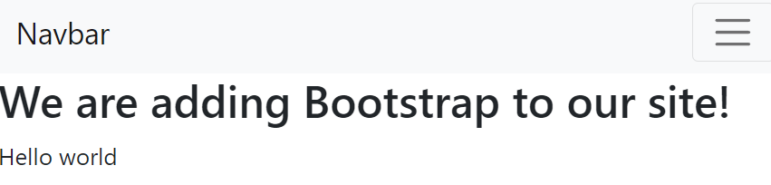
Large screen shows menu items horizontally spread out
Narrow screen size has “hamburger” menu; click the 3 bars to get dropdown of menu items
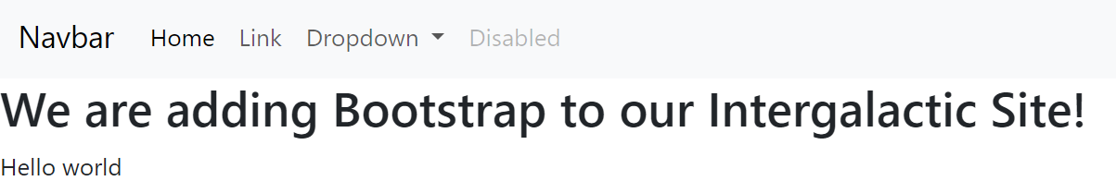
- Bootstrap uses CSS classes to define the appearances of HTML elements so that you can easily make changes just by modifying classes!
- Change the color scheme of the Navbar to suit your preferences: https://getbootstrap.com/docs/5.3/components/navbar/#color-schemes
- Here’s an example using <nav class="navbar navbar-expand-lg navbar-dark bg-success">
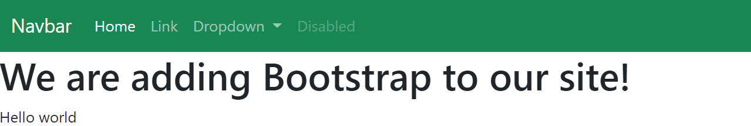
- Other built-in theme colors to try:
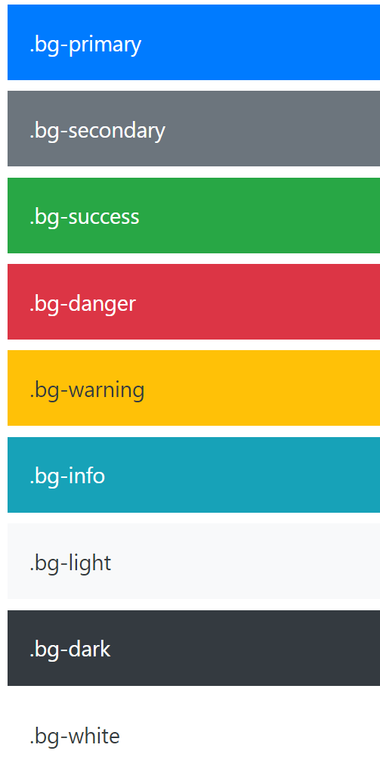
- Later, we will change to a different theme and explore the changes in colors

Responsive Images!
- Adding an image to your website can become time-consuming when the image doesn’t easily fit into your layout
- Example: I wanted to add the HTFW logo to the sample site by using an img tag like this:
<img src="hftw-dark.png" alt="Hack for the World logo">
But this is how it looked! Way out of proportion for the page:


- Simply adding the img-fluid class lets Bootstrap adjust the size to fit:
  - <img src="hftw-dark.png" class="img-fluid" alt="Hack for the World logo">
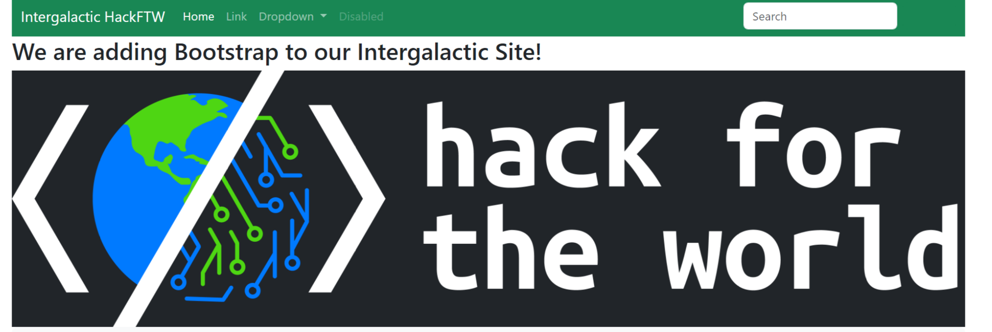

Jumbotron
- In previous versions of Bootstrap (prior to version 5) there was a really fun component named Jumbotron that had built-in settings to display content in a format to call attention to featured information; it was easy to add to your page by adding a div with class “jumbotron”. Sadly, the new Bootstrap has removed this class!
- Instead, Bootstrap has many utility classes that determine layout features such as height, width, padding, margin, font-weight, font-size. These are used to fine tune the Jumbotron look
- We can replicate the look of a jumbotron by copying one of their examples at https://getbootstrap.com/docs/5.3/examples/jumbotron/ Use Chrome so that we can use the DevTools
  - Right-click on the “jumbotron” you like and choose “inspect” from the pop-up menu to see the underlying HTML in DevTools; copy the <div> element that contains the full element. When you highlight the correct <div> in the HTML, you will see the entire element highlighted on the Web page. In the example below, the div and its contents are highlighted in green and blue on the left.
  - In the DevTools window right-click on the <div>, choose Copy, then Copy element to copy the entire <div> and its contents
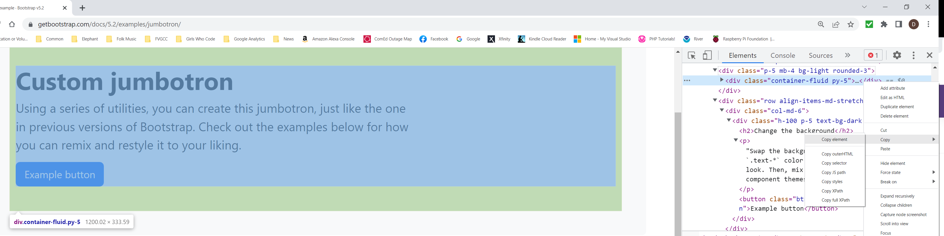
- Copy and paste the <div> to your page below the </nav> closing tag
- Modify the text and make any other changes you want and view your page again
- Our example code with “jumbotron” div highlighted :
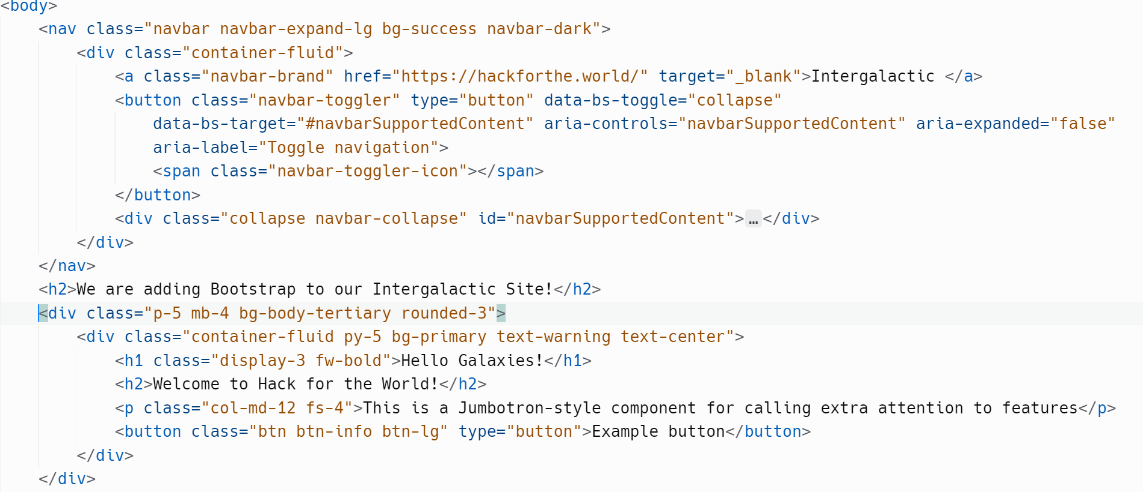
- This is how it looks so far:
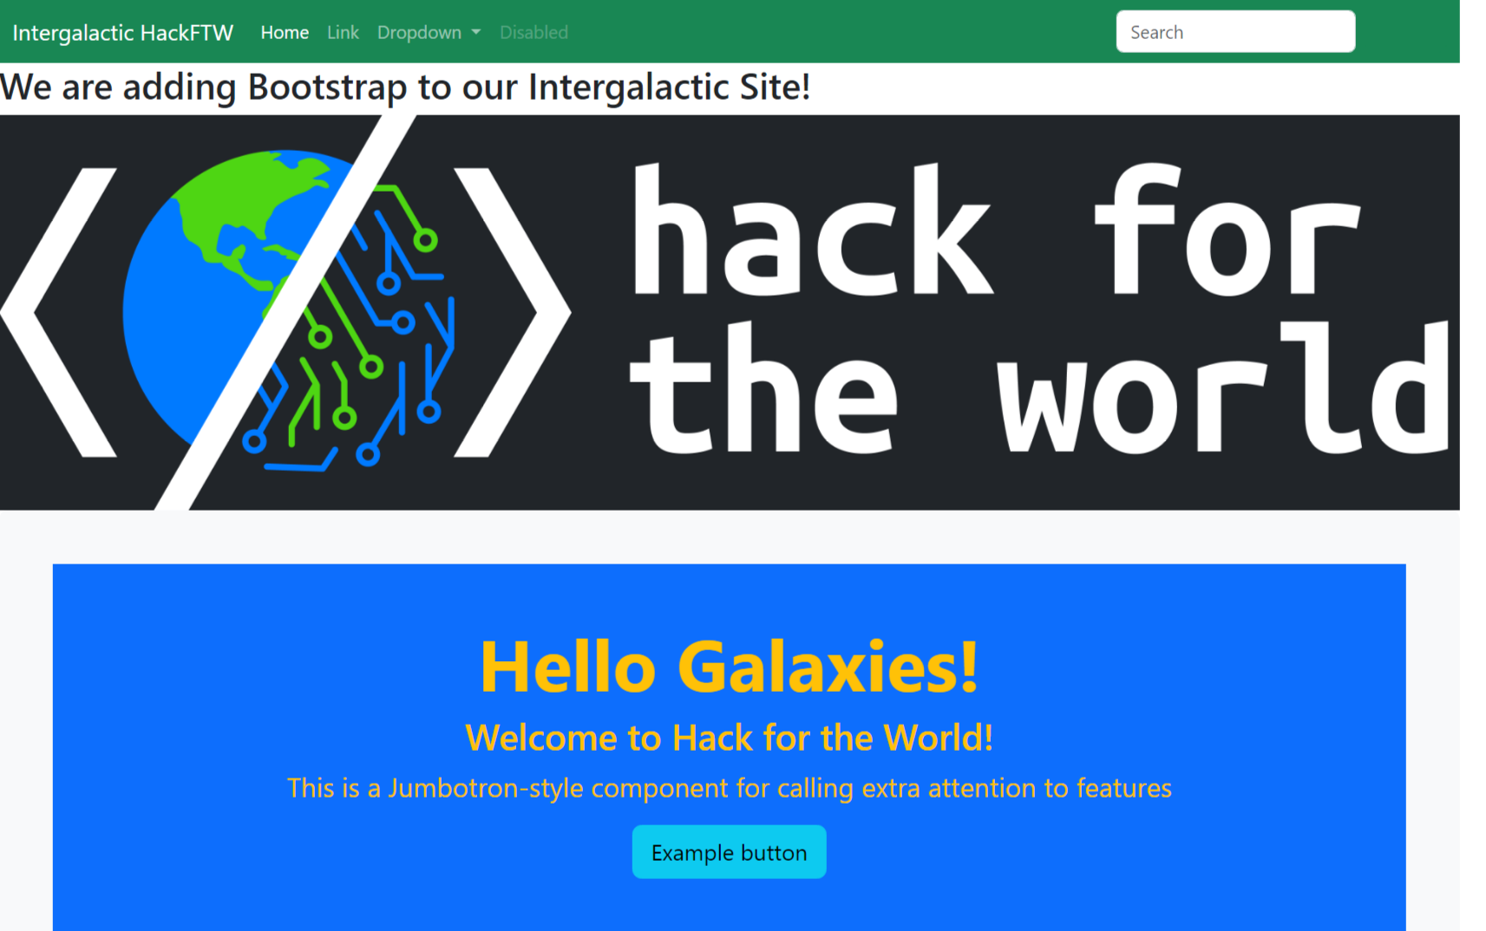

Buttons
Bootstrap has built-in styles for buttons with different color schemes based on purpose
- Go to https://getbootstrap.com/docs/5.3/components/buttons/
- Find the first code example on that page:
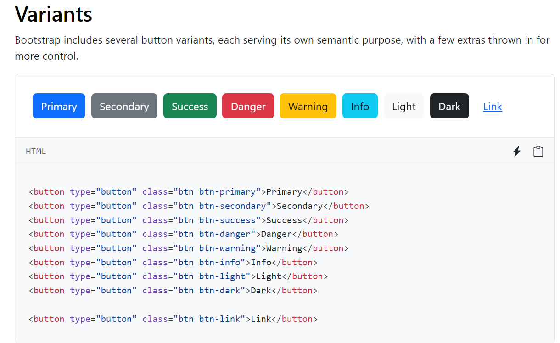
Click the copy icon to get the code

- Click the copy icon to get the HTML code into your clipboard
- In your project, add a pair of div tags <div> </div> and paste the code between them; add the classes class="container p-5 mx-auto"> to the div tag to center the new component:
<div id="buttons" class="container p-5 mx-auto">
<button type="button" class="btn btn-primary">Primary</button>
<button type="button" class="btn btn-secondary">Secondary</button>
<button type="button" class="btn btn-success">Success</button>
<button type="button" class="btn btn-danger">Danger</button>
<button type="button" class="btn btn-warning">Warning</button>
<button type="button" class="btn btn-info">Info</button>
<button type="button" class="btn btn-light">Light</button>
<button type="button" class="btn btn-dark">Dark</button>
<button type="button" class="btn btn-link">Link</button>
</div>

Grids with Responsive Columns:
The grid system is described in the documentation at: https://getbootstrap.com/docs/5.3/layout/grid/
- Container: A grid is contained within an element with the container or container-fluid class
- Row: within the container are row elements
- Column: within each row are column elements. The grid system has 12 columns available per row. If want your content to be divided into columns within a row, use the “col” class or one of its variants. The columns within a row are evenly divided in widths by default. Specify the distribution of widths to get what you want. For example, you can have one column with class=”col-8” and another column with class=”col-4” to get your total width of 12.
- Try adding this example to your code; then experiment with changing column sizes:
<div container p-5 my-5 mx-auto">
<h3>Responsive Columns will adjust column widths to screen size </h3>
<div class="container text-center border">
<div class="row bg-info">
<div class="col border">col</div>
<div class="col border">col</div>
<div class="col border">col</div>
<div class="col border">col</div>
</div>
<div class="row bg-secondary">
<div class="col-8 border">col-8</div>
<div class="col-4 border">col-4</div>
</div>
</div>
</div>
Run the project; the page should look something like this:
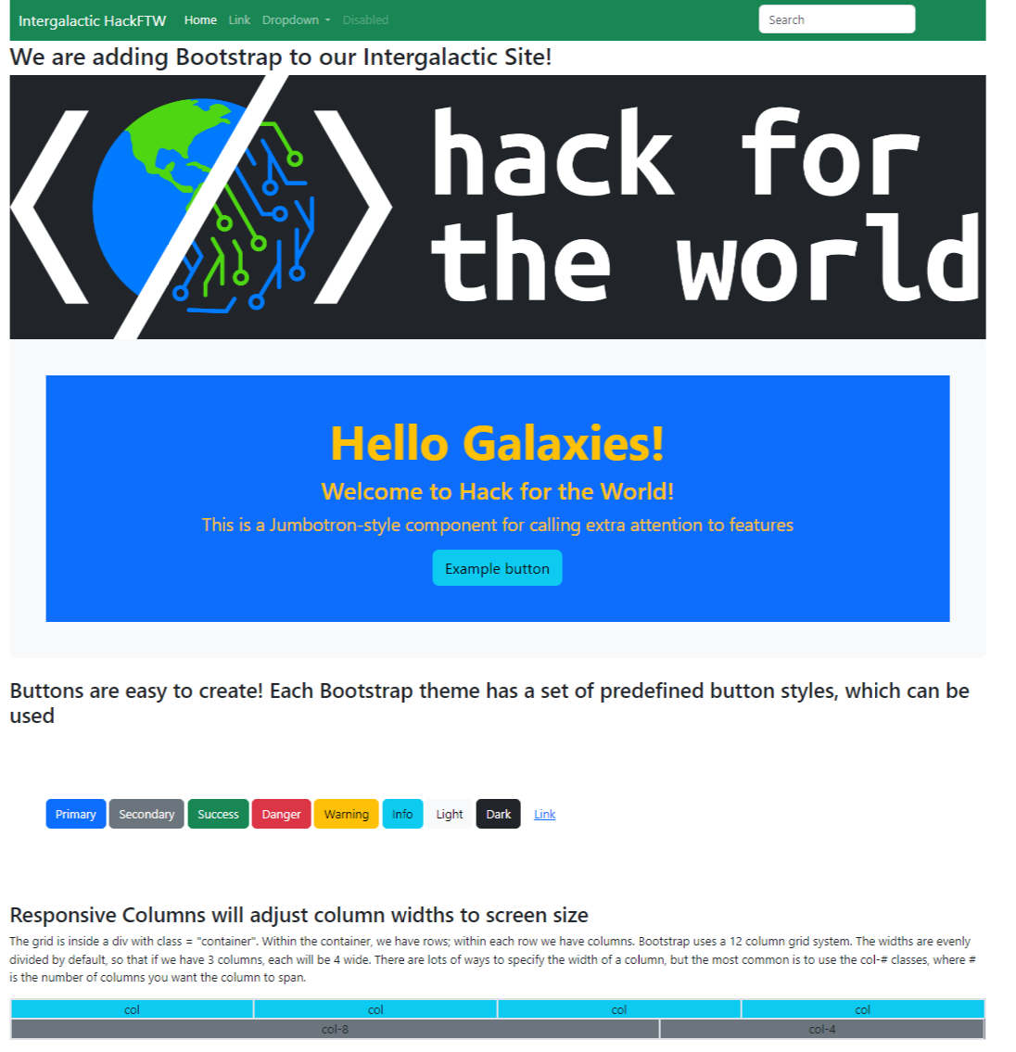

Change the Theme!
- Bootstrap consists of JavaScript and CSS; it is the CSS that affects the appearance, so we can easily change the look by changing the CSS
- Go to Bootswatch.com
- Find an appealing theme and click the Preview button; when you find one you like click the arrow next to Download. I’m trying out Solar to suit our intergalactic theme. Choose bootstrap.css from the list. The file will be downloaded to your usual downloads folder
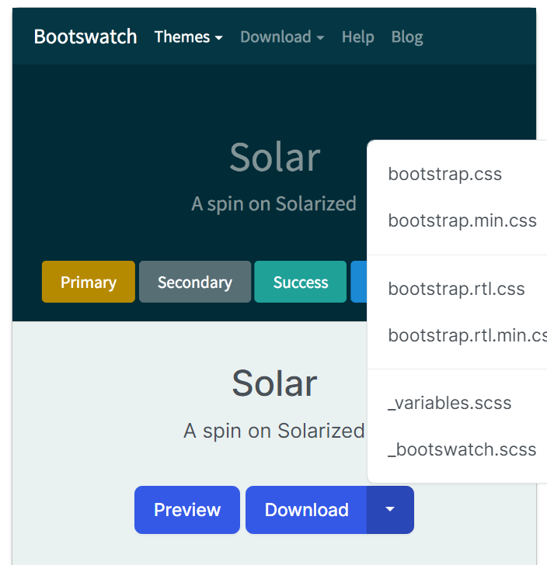
- Create a new webpage to test your theme: copy your index.html file so we can compare the 2 versions of Bootstrap. Click the 3 dots next to index.html and select Duplicate
    - 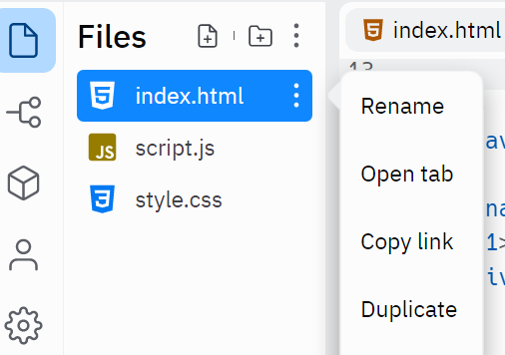
- Rename the copy to “theme.html” and select it for editing
- Upload the theme’s css file: In your Replit project, click the 3 dots above the file list, then “Upload a File”, then select the bootstrap.css file from your Downloads folder; click “open” to upload it
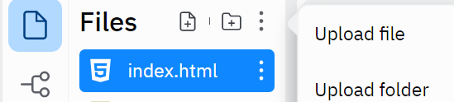
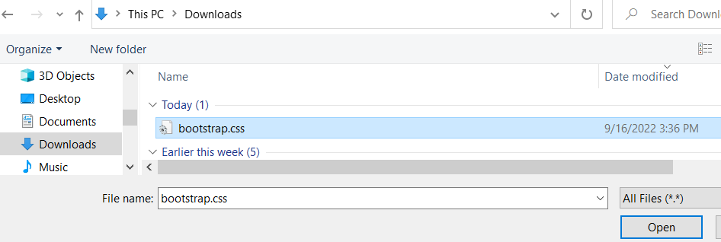
- In your new “theme.html” file, replace the existing bootstrap css link with your new file:
  - Find the link for bootstrap.min.css in the header <link href="https://cdn.jsdelivr.net/npm/bootstrap@5.2.1/dist/css/bootstrap.min.css" rel="stylesheet" integrity="sha384-iYQeCzEYFbKjA/T2uDLTpkwGzCiq6soy8tYaI1GyVh/UjpbCx/TYkiZhlZB6+fzT" crossorigin="anonymous">
  - Change it to this: <link rel="stylesheet" href="bootstrap.css" />
- Run your project and go to the new page by adding /theme.html to the end of the url : for our example, it is https://4df7cc67-6011-4f91-a4e1-052aab9db713-00-3j5jj2akz6byh.kirk.replit.dev/theme.html
- And, just like that, we have a whole new look!
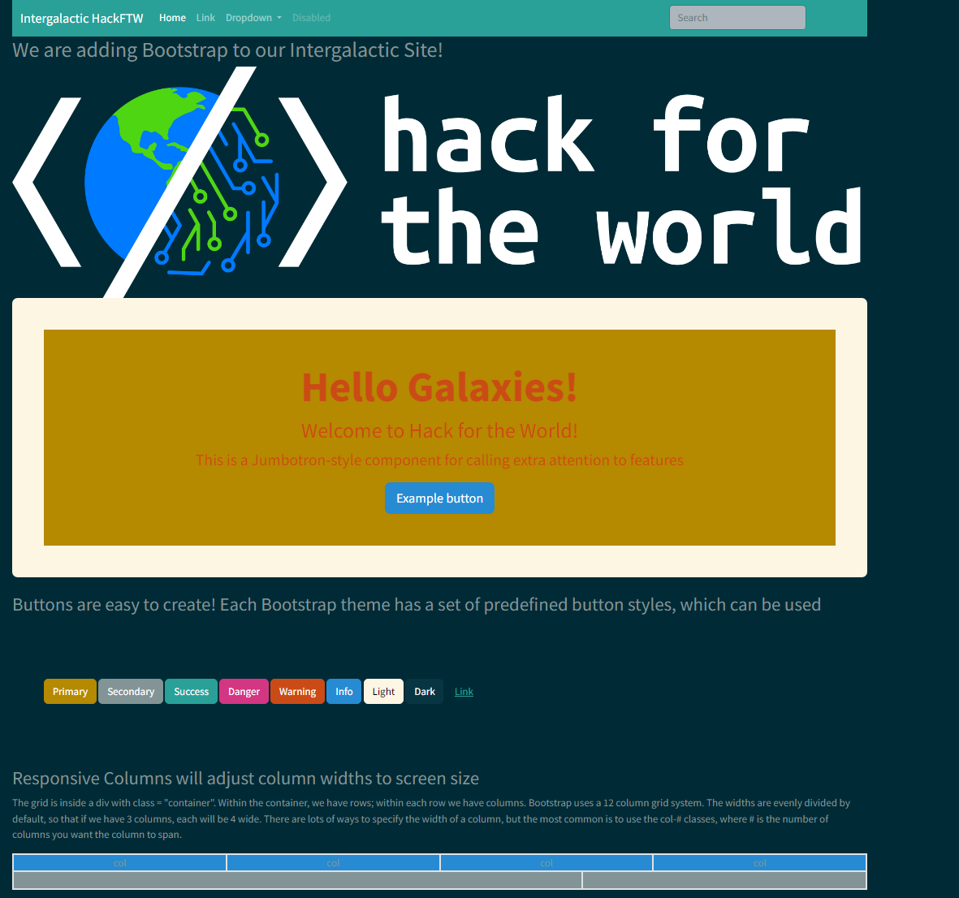

Update your Navbar to navigate between pages!
- Inside the Navbar html on index.html find this nav-link <a class="nav-link" href="#">Link</a>
- The value assigned to the href attribute tells the Browser where to go when the link is clicked; currently the value is “#” which doesn’t go anywhere. The text “Link” before the closing tag </a> is what is displayed for the link. We need to update the link for both of our pages
- Replace with <a class=”nav-link” href=”theme.html”>Theme</a>
- Do the same change in the Navbar for theme.html
- You also need to change 2 other links in the Navbar:
  - Find the “Brand” and change the href to “index.html” and the text to whatever you want to represent your brand:
<a class="navbar-brand" href="index.html">Intergalactic HackFTW</a>
  - Find the “Home link” and change the href to “index.html”:
<a class="nav-link active" aria-current="page" href="index.html">Home</a>

Learn more Bootstrap features by exploring a theme:
- Go back to https://bootswatch.com
- Select the theme you like and click the Preview button
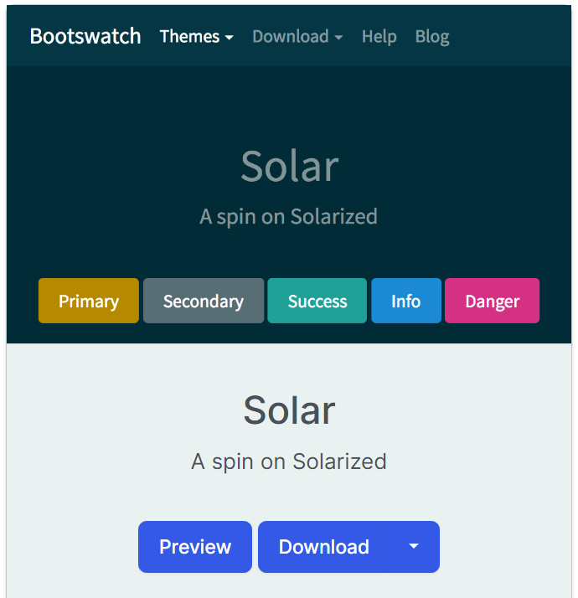

- The Solar one brings you to https://bootswatch.com/solar/
- Explore the page and find a component you’d like to add to your Web page. For many of these, you can hover over the component to get a < > icon to click to get a Source Code popup to copy code
- 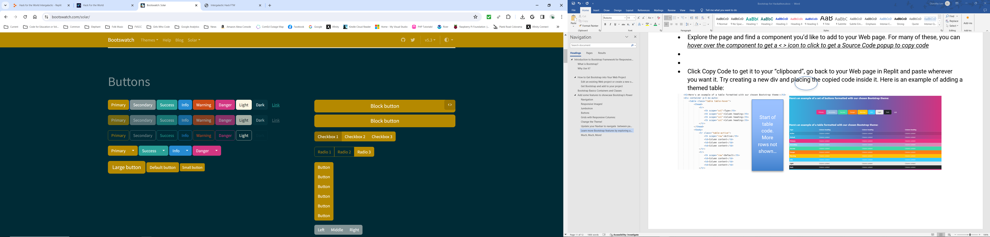
- 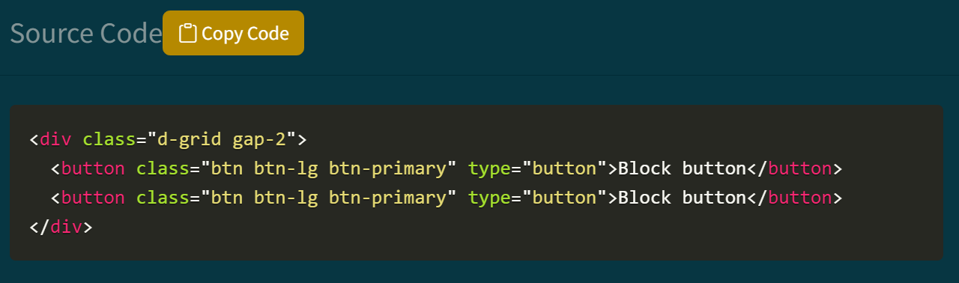
- Click Copy Code to get it to your “clipboard”, go back to your Web page in Replit and paste wherever you want it. Try creating a new div and placing the copied code inside it. Here is an example of adding a themed table in the Quartz theme:
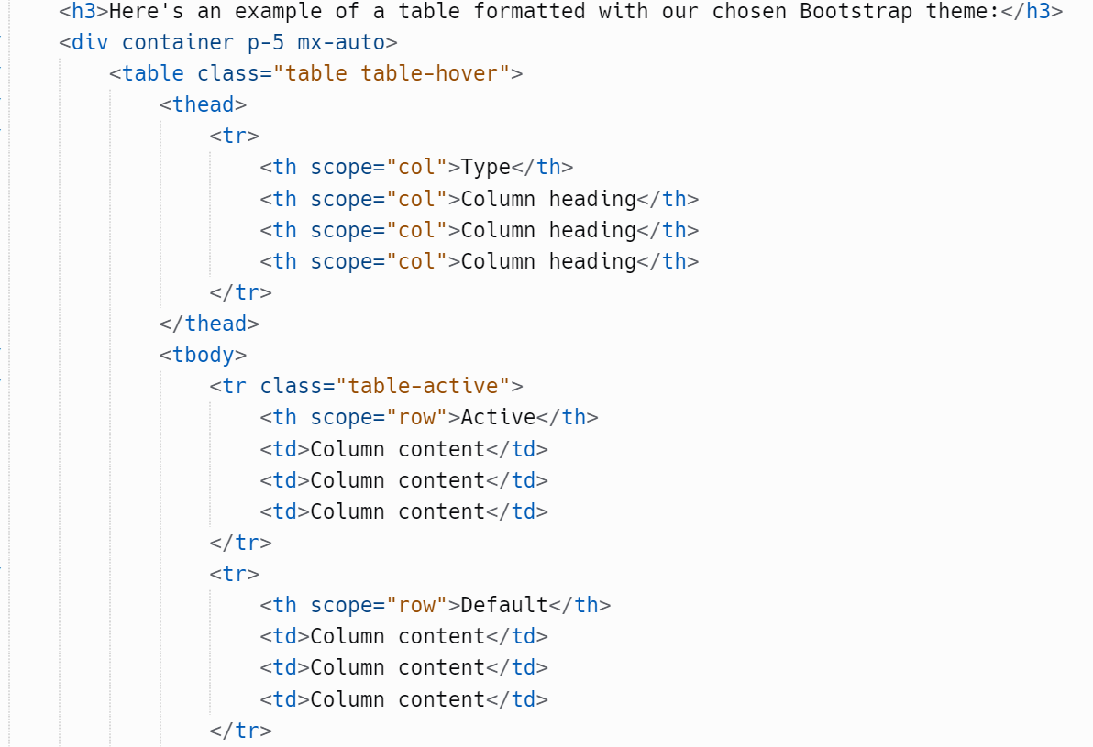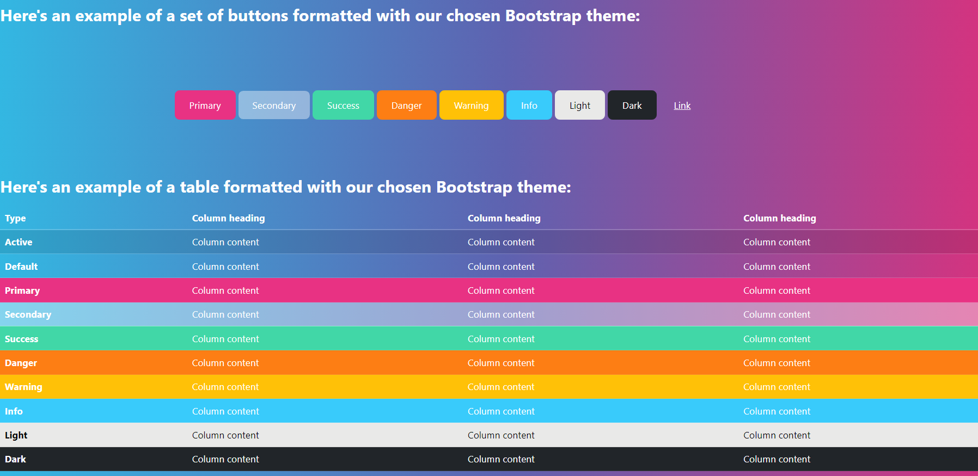
Start of table code. More rows not shown…

Much, Much, More!
- Explore using some of the other components using the examples from one of these sites:
  - Bootstrap: https://getbootstrap.com/
  - https://www.w3schools.com/bootstrap5/

Sample site used for the above examples:

https://hack-for-the-world-intergalactic-dottiefvgcc.replit.app/

